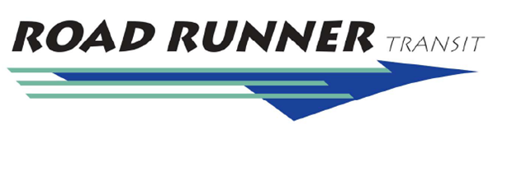
Date : December 2021

Performance Report: RRT

 | Ignacio | DAR | Bfld DAR
Vehicles in service: | 2 | 3
Vehicle Miles: | 5228 | 2678 | 0
Vehicle Hours** | 226:52:00 | 215:09:00 | 19:48:00
Passenger Total: | 340 | 585 | 56
Wheel Chair: | 1 | 0 | 0
Avg. Rider Per-Day | 11 | 19 | 2

**Driver hours also equal vehicle hours

Sr. Ridership
 | Ignacio | DAR | Bfld DAR
Total Riders | 138 | 155 | 7
Average | 5 | 5 | 1

Ignacio: 21Ops & 10 No Ops
DAR: 31 Ops & 0 No Ops

