**www.diversitykeynote.com**

2018

**From Suits To Tattoos**

Understanding Cultural and Generational Diversity

Kostas Voutsas, professor, consultant, motivational speaker



**Kostas Voutsas****, MBA MSHR/OD**

Assistant Professor of Business

Motivational Speaker-Author

Dickinson State University

1815 Schafer St.

Bismarck, ND 58506

PHONE: 701-224-2547

FAX: 701-224-5745

Website: [www.diversitykeynote.com](http://www.diversitykeynote.com)

Book: Secrets to Making Diversity Work, 2018

It was during my first week in America, when I asked my professor for a rubber. I am sure you get the idea. My professor looked at me confused so I asked again, “May I please borrow your rubber?” while I pointed at his eraser. The same night I had realized that although in British English rubber means eraser, in American English rubber means condom.

It was all Greek to me. I had just turned 21 when I arrived to Michigan from Greece to continue my studies at a local university. I had a rough first week in America. I got robbed at a gunpoint near campus, I asked someone where the nearest garage (gas station in American) was, I went to Subway and asked for biscuits instead of cookies, I asked my barber to trim my sideboards (sideburns), I placed my first trunk call (long distance call), and I purchased my first Polo jumper (sweater).

The reason why I created confusion is that I learned British English in a Greek private school since I was nine years old. I had not realized that British and American English differ.

I never experienced cultural differences in Greece. Growing up in a homogeneous beautiful country, you were surrounded with white people, mostly Greeks, Greek food, Greek history, Greek language, Greek customs, Greek traditions and Greek everything.

I first realized that cultural differences exist during my overseas flight to America. It all started when I loudly screamed, “I lost my purse, I lost my purse.” “Sir, please calm down!” said the German airhostess as she handed my missing wallet. When she asked me if everything was in place, I signaled OK to her using the ring gesture (thumb and index circle), not knowing that this gesture in Germany is a reference to the receiver’s anatomy. Not only did the airhostess face drop, but my Brazilian co passenger’s face as well.

You see, the ring or OK gesture in Brazil is also an offensive gesture. From that moment, I had just created my first two enemies without even realizing it. I could not understand why both women where not as friendly as before. I could not understand what I have said to offend them. It was a mystery. It took years to realize that it was not what I have said that created the confusion; it was my body language that communicated the wrong signal.

This specific gesture has different meanings based on the culture. As the table below shows, the ring gesture means OK in the U.S., the person is worth nothing in Tunisia, a warning for one to be alert in Italy, zero or worthless in France, insulting gesture in Germany and Brazil, and money in Japan.



**Is time money?**

In America time in money. Being a monochromic culture like Germany, Switzerland, Japan, Hong Kong China, being on time is a must. Schedules and time tables are serious business. Could you imagine showing up at work late every day or taking extra breaks? Based on a Levine and Bartlett’s study, the graphs below show that time perception is relative, depending on the culture.



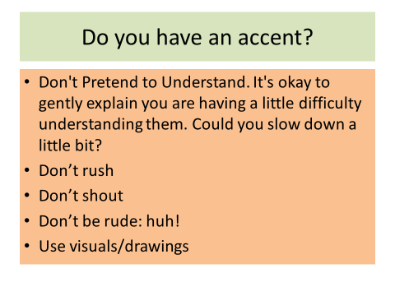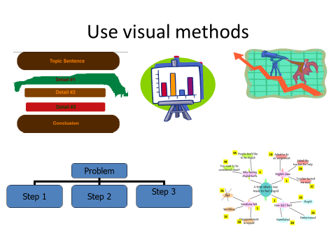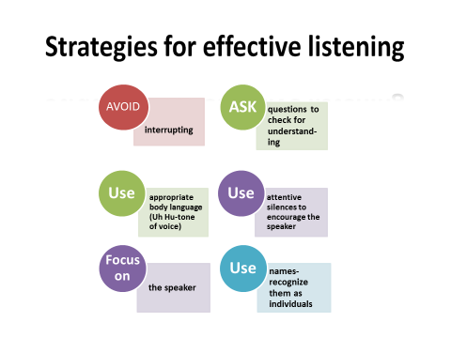

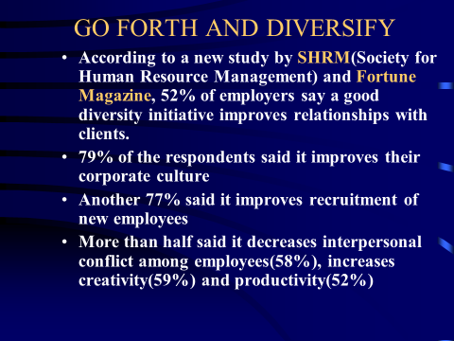

**From Suits to Tattoos: Decoding Generational Differences**

How often do you hear the following: “I can’t believe he texted in sick!” “Why do I need to be at work at 8:00am since no one does anything before 10:00am?”

Today’s U.S. workforce employs five generations at the same time, including Traditionalists (70 and up), Boomers (51 to 69), Generation X (39-50), Generation Y (25-38), and Generation Z (16 to 24).

**Traditionalists** created corporate America. They are loyal, formal, conservative, demand respect from younger employees, and respect authority. They prefer making decisions based on what has worked in the past.

**Boomers** are a hard working generation. They are loyal with strong work ethic. Although they are highly competitive, Boomers value teamwork, diversity, change, and collaboration.

**Gen Xers** saw their parents working hard and decided to work smart. They value work flexibility, diversity, and are results oriented. They are efficient, entrepreneurial, creative, and want structure and direction.

**Gen Yers** are creative, open-minded, fiercely competitive, confident, and innovative multi-taskers. It’s amazing to me how some of my college students type up their business reports while chatting on Facebook, listening to their iPods, and watching their favorite blue ray movie at the same time. And they succeed in all these tasks!

**Gen Z** is the first generation to be raised in the era of smartphones. Gen Z employees are independent, innovative and entrepreneurial. This generation is more global in its thinking. Generation Z takes in information instantaneously and loses interest just as fast.

Understanding generational differences is the key to effective business communication. Education and training on the different generations will increase awareness and will help foster healthy work environments. To better manage generational differences, provide feedback when needed. Traditionalists and Boomers will be satisfied with an annual formal evaluation. Provide informal feedback to Gen Xers and Yers frequently. Another solution is to partner different generations to work together on a project or activity. Make sure to balance the roles and responsibilities so that all generations engage in leadership.

 “The key to managing four generations in the workforce is to value the different thoughts, ideas, experiences, and values each employee brings into your organization,” says Central Dakota Human Resource Association President-Elect Jason Sutheimer. “When employees know they are valued for these differences they are more open about providing opinions on issues which will help you solve problems in ways you have never imagined.”

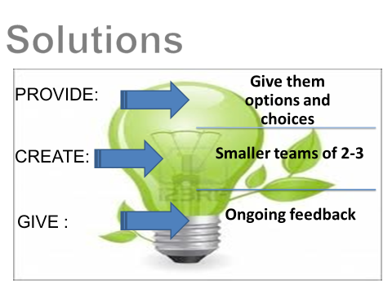

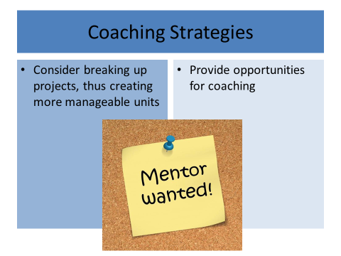



Kostas Voutsas is an assistant professor of DSU at BSC and a motivational speaker. You may contact Kostas at www.diversitykeynote.com.